**SHERATON MALDIVES FULL MOON RESORT & SPA EMBRACES LOCAL CULTURE AND PARTNERS   
IN FESTIVE ARTISAN MARKET**

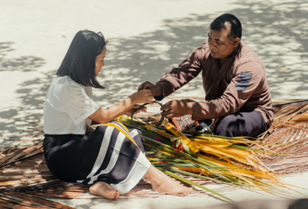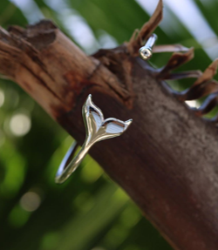

*Guests are invited to partake in shopping, community, and enriching cultural experiences*

**[LINK TO PRESS KIT](https://marrstar.box.com/s/ak1s8c9y8y5p14p05dlkq96p16258mi3)**

**Maldives, November 2023:** Set against the breathtaking backdrop of Furanafushi Island in North Male Atoll, [Sheraton Maldives Full Moon Resort and Spa](https://www.marriott.com/en-us/hotels/mlesi-sheraton-maldives-full-moon-resort-and-spa/overview/) is thrilled to announce the return of its Festive Artisan Market. This highly anticipated festive celebration takes place at the tranquil Kakuni beach on December 27, 2023, from 1 PM to 5 PM.

The Festive Artisan Market is a day of shopping and community experiences. It boasts an impressive lineup of curated collections, providing a diverse range of local artisans and designers, and offering guests a unique and immersive experience. Participants can indulge in the collection of beach essentials, including tote bags, hats, and exquisite jewelry from *See from the Sky*. *Tropical Designs* offers delicate and intricate jewelry collections inspired by the beauty of the tropics, while *Anbalange* showcases authentic craftsmanship of beads and stones with a modern twist. For those seeking custom-made Maldivian resin artwork, *THONArtisan* delivers a personalized touch to artistic expression. *Amoriere* invites you to immerse in relaxation with hand-poured scented candles that capture the essence of the Maldives.

In addition to the attractive displays, guests are invited to partake in enriching activities that provide a glimpse into the vibrant Maldivian culture. From palm weaving and coconut grating to savoring delectable Maldivian snacks, there is something for everyone to enjoy.

General Manager of Sheraton Maldives Full Moon Resort & Spa, Mohamed El Aghoury, expresses, "We are delighted to host the Festive Artisan Market once again, showcasing the talent of local artisans and designers. This event not only aligns with our commitment to supporting the local community but also allows our guests to experience the rich cultural tapestry of the Maldives. We believe in providing unique and memorable experiences, and the Festive Artisan Market is a testament to that commitment. We look forward to welcoming guests to Kakuni Beach for a day filled with creativity, culture, and festivity."

Sheraton Maldives Full Moon Resort & Spa is the perfect place to relax this holiday season and enjoy the Maldivian way of life. Guests can immerse themselves in a variety of water sports, excursions, and dining options, which promises convenient travel with a 15-minute speedboat ride away from Velana International Airport. The resort offers 176 guest rooms designed to blend into the surrounding turquoise waters, pristine beaches, and lush greenery. Also boasting 7 unique restaurants and bars, the Shine Spa for Sheraton located on its very own island and 3 outdoor tropical fresh water pools.

**– ENDS –**

**About Sheraton Maldives Full Moon Resort & Spa**

Sheraton Maldives Full Moon Resort & Spa is situated on the private island of Furanafushi in the Republic of Maldives, a 15-minute speedboat ride away from Velana International Airport. The resort is among the first resorts to offer complimentary transfers to its discerning guests. The five-star resort offers 176 guest rooms designed to blend into the surrounding turquoise waters, pristine beaches, and lush greenery. In addition to 7 unique restaurants and bars, the Shine Spa for Sheraton is located on its very own island and 3 outdoor tropical freshwater pools, the resort caters to all guests and is the perfect destination for honeymooners, families with young children or teens, and solo travelers alike.

**About Sheraton® Hotels & Resorts**

Sheraton Hotels & Resorts makes it easy for guests to feel welcome at over 430 hotels and resorts in nearly 70 countries and territories around the world. As the most global brand within Marriott Bonvoy’s portfolio of extraordinary hotel brands sitting at the center of hundreds of communities around the world, Sheraton has a rich heritage in creating a sense of belonging for guests, wherever they are in the world. Sheraton is currently undergoing a major brand transformation, creating a signature community experience for the next generation of travelers and locals alike at properties across the globe. The new vision for Sheraton features intuitive design, tech-forward experiences, and upgrades to everything from public space and F&B to flexible meeting space. For more information, please visit [www.sheraton.com](http://www.sheraton.com/), and stay connected on [Facebook](https://www.facebook.com/Sheraton/), and @sheratonhotels on [Twitter](https://twitter.com/sheratonhotels?lang=en) and [Instagram](https://www.instagram.com/sheratonhotels/?hl=en). Sheraton is proud to participate in Marriott Bonvoy®, the global travel program from Marriott International. The program offers members an extraordinary portfolio of global brands, exclusive experiences on [Marriott Bonvoy Moments](https://moments.marriottbonvoy.com/), and unparalleled benefits including free nights and Elite status recognition. To enroll for free or for more information about the program, visit [marriottbonvoy.com](https://www.marriott.com/loyalty.mi).

**Media Contacts**

Teges Triguna

Marketing & Communications Manager

Sheraton Maldives Full Moon Resort & Spa

Email: [teges.triguna@sheraton.com](mailto:teges.triguna@sheraton.com)